Intersex Genital Mutilations
Human Rights Violations Of Children
With Variations Of Reproductive Anatomy

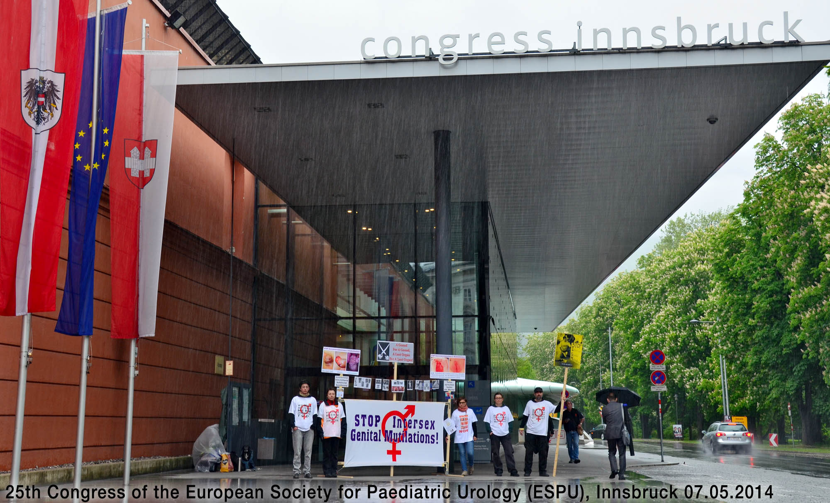

NGO Report (for Session)
to the 9th Periodic Report of Austria
on the Convention on the Elimination of
All Forms of Discrimination against Women (CEDAW)
Compiled by:

StopIGM.org / Zwischengeschlecht.org (International Intersex Human Rights NGO)
Markus Bauer, Daniela Truffer
Zwischengeschlecht.org
P.O.Box 2122
CH-8031 Zurich
info_at_zwischengeschlecht.org
http://Zwischengeschlecht.org/
http://stop.genitalmutilation.org/

June 2019

This NGO Report online:
PDF: http://intersex.shadowreport.org/public/2018-CEDAW-Austria-NGO-Zwischengeschlecht-Intersex-IGM.pdf
DOCX: http://intersex.shadowreport.org/public/2018-CEDAW-Austria-NGO-Zwischengeschlecht-Intersex-IGM.docx

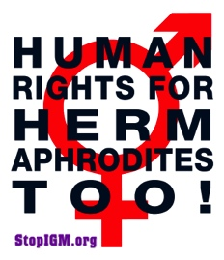
Executive Summary
As reiterated by the State party in its Reply to the LOI, in Austria all typical forms of Intersex Genital Mutilation continue unchanged and with impunity, facilitated and paid for by the State party via the public health system. Intersex children still have no legal protection from harmful practices, and data on IGM is kept hidden by the Government.
Austria is thus in breach of its obligations under article 5 of the Convention to (a) take effective legislative, administrative, judicial or other measures to eliminate harmful practices on intersex children, namely IGM practices, (b) to ensure access to justice, redress, compensation and rehabilitation for victims, and c) to provide families with intersex children with adequate psychosocial and peer support.
CAT has already considered IGM in Austria as constituting at least cruel, inhuman or degrading treatment (CAT/C/AUT/CO/6, paras 44–45). Nonetheless, to this day the Austrian Government fails to act.
This Committee has repeatedly considered IGM as a harmful practice, and the CEDAW/CRC Joint general recommendation No. 31/18 on harmful practices as applicable. In total, UN treaty bodies CEDAW, CRC, CAT, CCPR and CRPD have so far issued 42 Concluding Observations on IGM, typically obliging State parties to enact legislation to (a) end the practice, (b) ensure redress and compensation, plus (c) access to free counselling. Also the UN Special Rapporteurs on Torture (SRT) and Health (SRH), the UN High Commissioner for Human Rights (UNHCHR), the World Health Organisation (WHO), the Inter-American Commission on Human Rights (IACHR), the African Commission on Human and Peoples’ Rights (ACHPR) and the Council of Europe (COE) recognise IGM as a serious violation of non-derogable human rights.
Intersex people are born with Variations of Reproductive Anatomy, including atypical genitals, atypical sex hormone producing organs, atypical response to sex hormones, atypical genetic make-up, atypical secondary sex markers. While intersex people may face several problems, in the “developed world” the most pressing are the ongoing Intersex Genital Mutilations, which present a distinct and unique issue constituting significant human rights violations.
IGM practices include non-consensual, medically unnecessary, irreversible, cosmetic genital surgeries, and/or other harmful medical procedures that would not be considered for “normal” children, without evidence of benefit for the children concerned. Typical forms of IGM include “masculinising” and “feminising”, “corrective” genital surgery, sterilising procedures, imposition of hormones, forced genital exams, vaginal dilations, medical display, involuntary human experimentation and denial of needed health care.
IGM practices cause known lifelong severe physical and mental pain and suffering, including loss or impairment of sexual sensation, painful scarring, painful intercourse, incontinence, urethral strictures, impairment or loss of reproductive capabilities, lifelong dependency of artificial hormones, significantly elevated rates of self-harming behaviour and suicidal tendencies, lifelong mental suffering and trauma, increased sexual anxieties, and less sexual activity.
For 25 years, intersex people have denounced IGM as harmful and traumatising, as western genital mutilation, as child sexual abuse and torture, and called for remedies.
This NGO Report has been compiled by the international intersex NGO StopIGM.org / Zwischengeschlecht.org. It contains Suggested Recommendations (see p. 14).
NGO Report (for Session)
to the 9th Periodic Report of Austria
on the Convention on the Elimination of All Forms
of Discrimination against Women (CEDAW)

Table of Contents

IGM Practices in Austria (p. 5–14)

Executive Summary 3
Table of Contents 4
A. Introduction 5
1. Update: Intersex, IGM and Human Rights in Austria 5
2. About the Rapporteurs 5
3. Methodology 5
B. Precedents 6
1. 2016 CAT Concluding Observations on Intersex (CAT/C/AUT/CO/6, paras 44–45) 6
2. 2018 List of Issues on Intersex (CEDAW/C/AUT/Q/9, para 11) 7
3. 2019 Reply to the List of Issues on Intersex (CEDAW/C/AUT/Q/9/Add.1, paras 67-69) 7
C. IGM in Austria: Still State-sponsored and pervasive, Gov fails to act 8
1. Update: Still no protections, IGM practices continue unchanged (art. 5) 8
2. The Treatment of Intersex Children in Austria as a Harmful Practice and Violence 8
a) Harmful Practice (art. 5 and JGR No. 31) 8
b) Violence (arts. 1 and 2 in conjunction with General recommendation No. 35) 9
3. Lack of Legislative Provisions to Ensure Protection from IGM Practices,
Impunity of the Perpetrators (art. 5 and JGR No. 31; art. 2 and GR No. 35) 10
4. Obstacles to Redress, Fair and Adequate Compensation, and Rehabilitation
(art. 5 and JGR No. 31; art. 2 and GR No. 35) 11
D. Claims of the Austrian Government in its Replies to the LOI 12
1. Claim “Civil Register Issues are a valid Answer to Harmful Practices” 12
2. Claim “Constitutional Court did not comment on IGM Practices” 12
3. Claim “In Absence of effective Consent, Intersex People can claim Compensation” 13
4. Claim “There are no statistical Data on IGM Practices” 13
Suggested Recommendations 14
Annexe – “IGM in Medical Textbooks: Current Practice” 15
IGM 1 – “Masculinising Surgery”: “Hypospadias Repair” 15
IGM 2 – “Feminising Surgery”: “Clitoral Reduction”, “Vaginoplasty” 17
IGM 3 – Sterilising Surgery: Castration / “Gonadectomy” / Hysterectomy 19
“Bad results” / “Gonadectomy, Feminizing Genitoplasty” 21

A. Introduction
1. Update: Intersex, IGM and Human Rights in Austria
As directly and indirectly confirmed by the State party’s reply to the List of Issues (paras 67-69) and further demonstrated in this NGO report, the situation in Austria hasn’t changed: IGM practices still continue with impunity, intersex children still have no legal protections from harmful practices, and the Government still refuses to disclose available data on IGM, despite the previous 2015 CAT recommendations recognising IGM in Austria as inhuman treatment.

2. About the Rapporteurs
This NGO report has been prepared by the international intersex NGO StopIGM.org / Zwischengeschlecht.org:
- StopIGM.org / Zwischengeschlecht.org is an international intersex human rights NGO based in Switzerland, working to end IGM practices and other human rights violations perpetrated on intersex people, according to its motto, “Human Rights for Hermaphrodites, too!” According to its charter, StopIGM.org works to support persons concerned seeking redress and justice and regularly reports to relevant UN treaty bodies, often in collaboration with local intersex persons and organisations, substantially contributing to the so far 42 Treaty body Concluding Observations recognising IGM as a serious human rights violation.
StopIGM.org has been active in Austria since 2011, documenting the ongoing practice, publicly confronting individual perpetrators and hospitals, has been consulted by the CRC NHRI Child and Youth Advocates Austria (KIJOE), supporting IGM survivors to testify at the UN, and has previously reported on IGM in Austria to CAT in 2015 (in collaboration with Verein Intergeschlechtlicher Menschen Österreich VIMÖ) and in 2017, and to CRPD and CEDAW in 2018.

3. Methodology
This thematic NGO report is an update to the 2018 CEDAW Austria PSWG NGO Report by the same Rapporteurs, which was in part based on the 2015 CAT Austria NGO Report in collaboration with Verein Intergeschlechtlicher Menschen Österreich VIMÖ.
B. Precedents

1. 2016 CAT Concluding Observations on Intersex (CAT/C/AUT/CO/6, paras 44–45)

Intersex persons
44. The Committee appreciates the assurances provided by the delegation that surgical interventions on intersex children are carried out only when necessary, following medical and psychological opinions. It remains concerned, however, about reports of cases of unnecessary surgery and other medical treatment with lifelong consequences to which intersex children have been subjected without their informed consent. The Committee is further concerned at the lack of legal provisions providing redress and rehabilitation in such cases (arts. 14 and 16).
45. The State party should:
(a) Take the legislative, administrative and other measures necessary to guarantee the respect for the physical integrity and autonomy of intersex persons and to ensure that no one is subjected during infancy or childhood to non-urgent medical or surgical procedures intended to decide the sex of the child;
(b) Guarantee impartial counselling services for all intersex children and their parents, so as to inform them of the consequences of unnecessary and non-urgent surgery and other medical treatment to decide on the sex of the child and the possibility of postponing any decision on such treatment or surgery until the persons concerned can decide by themselves;
(c) Guarantee that full, free and informed consent is ensured in connection with medical and surgical treatments for intersex persons and that non-urgent, irreversible medical interventions are postponed until a child is sufficiently mature to participate in decision-making and give effective consent;
(d) Undertake investigation of instances of surgical interventions or other medical procedures performed on intersex persons without effective consent and ensure that the persons concerned are adequately compensated.

2. 2018 List of Issues on Intersex (CEDAW/C/AUT/Q/9, para 11)

Stereotypes and harmful practices
[…]
11. Please provide information, including detailed statistics, on legal and medical standards following best practices in relation to medical and surgical treatment of intersex persons, on investigations into incidents of involuntary sterilization or unnecessary and irreversible surgical or other medical treatment, very often done without the informed consent of the patient, and on existing remedies to the victims of such treatment, including adequate compensation. Please also indicate how many persons have registered as a third gender, following its legal recognition by the Constitutional Court in June 2018.

3. 2019 Reply to the List of Issues on Intersex
(CEDAW/C/AUT/Q/9/Add.1, paras 67-69)

Regarding Issue 11
67. In its judgment from 15 June 2018, the Constitutional Court held that intersex people, who are biologically neither clearly “male” nor “female”, have the right to be registered according to their sex characteristics in the civil register or in official documents. A ministerial working group clarified issues related to the civil register.
68. The Court did not comment on legal or medical requirements for medical interventions for intersex people in its decision. From a tort law perspective, any medical treatment that harms a person’s physical integrity is considered a bodily injury and therefore unlawful. Only effective consent of the person concerned can justify such an unlawful intervention. In absence of effective consent, it can be assumed that compensation can be claimed for the treatment of intersex people.
69. There are no statistical data on medical and surgical interventions in intersex people.

C. IGM in Austria: Still State-sponsored and pervasive, Gov fails to act
1. Update: Still no Protections, IGM Practices continue with Impunity (art. 5)
As directly and indirectly confirmed by the State party’s reply to the List of Issues (see also below p. 12-13) and further demonstrated in this NGO report, the situation hasn’t changed:
In Austria (CAT/C/AUT/CO/6, paras 44–45), same as in the neighbouring states of Germany (CEDAW/C/DEU/CO/7-8, paras 23-24; CAT/C/DEU/CO/5, para 20; CRPD/C/DEU/CO/1, paras 37-38), Switzerland (CEDAW/C/CHE/CO/4-5, paras 38-39; CRC/C/CHE/CO/2-4, paras 42-43; CAT/C/CHE/CO/7, para 20; CCPR/C/CHE/CO/4, paras 24-25), and in many more State parties, there are
- still no effective legal or other protections in place to ensure the rights of intersex children to physical and mental integrity, autonomy and self-determination, and to prevent IGM
- still no measures in place to ensure systematic data collection and monitoring of IGM
- still no legal or other measures in place to ensure the accountability of IGM perpetrators
- still no legal or other measures in place to ensure access to redress and justice for adult IGM survivors
To this day, the Austrian government allows IGM practices to continue with impunity and against better knowledge – all the practices documented in our PSWG report (p. 11-13) continue unchanged.
Also, the State party still refuses to disaggregate and disseminate available data on IGM practices (see also below p. 13), and access to adequate psychosocial counselling and peer support for intersex persons and their families still remains sorely lacking.
2. The Treatment of Intersex Children in Austria as a Harmful Practice and Violence
a) Harmful Practice (art. 5 and JGR No. 31)
Article 5 (a) CEDAW calls on states to eliminate harmful “prejudices and customary and all other practices which are based on the idea of the inferiority or the superiority of either of the sexes or on stereotyped roles for men and women”. While the initial point of reference for the term was the example of Female Genital Mutilation/Cutting (FGM/C), the term consciously wasn’t limited to FGM/C, but meant to include all forms of harmful, violent, and/or invasive traditional or customary practices.
The Committee has repeatedly considered IGM as a harmful practice, and the CEDAW/CRC Joint general recommendation No. 31/18 on harmful practices as applicable.

Harmful practices (and inhuman treatment) have been identified by intersex advocates as the most effective, well established and applicable human rights frameworks to eliminate IGM practices and to end the impunity of the perpetrators.
The Joint general recommendation No. 31 “on harmful practices” “call[s] upon States parties to explicitly prohibit by law and adequately sanction or criminalize harmful practices, in accordance with the gravity of the offence and harm caused, provide for means of prevention, protection, recovery, reintegration and redress for victims and combat impunity for harmful practices” (para 13).
Particularly, the Joint general recommendation further underlines the need for a “Holistic framework for addressing harmful practices” (paras 31–36), including “legislative, policy and other appropriate measures that must be taken to ensure full compliance with [state parties’] obligations under the Conventions to eliminate harmful practices” (para 2), as well as
- “Data collection and monitoring” (paras 37–39)
- “Legislation and its enforcement” (paras 40–55), particularly:
- “adequate civil and/or administrative legislative provisions” (para 55 (d))
- “provisions on regular evaluation and monitoring, including in relation to implementation, enforcement and follow-up” (para 55 (n))
- “equal access to justice, including by addressing legal and practical barriers to initiating legal proceedings, such as the limitation period, and that the perpetrators and those who aid or condone such practices are held accountable” (para 55 (o))
- “equal access to legal remedies and appropriate reparations in practice” (para 55 (q)).
Last but not least, the Joint general recommendation explicitly stipulates: “Where medical professionals or government employees or civil servants are involved or complicit in carrying out harmful practices, their status and responsibility, including to report, should be seen as an aggravating circumstance in the determination of criminal sanctions or administrative sanctions such as loss of a professional licence or termination of contract, which should be preceded by the issuance of warnings. Systematic training for relevant professionals is considered to be an effective preventive measure in this regard.” (para 50)
Thus, IGM practices in Austria – as well as the failure of the state party to enact effective legislative, administrative, social and educational measures to eliminate them and to ensure effective access to remedies and redress – clearly violate Article 5 CEDAW, as well as the CEDAW/CRC Joint general recommendation No. 31/18 on harmful practices.

b) Violence (arts. 1 and 2 in conjunction with General recommendation No. 35)
In addition, due to their nature, IGM practices clearly also constitute a form of gender-based violence, and thus also articles 1 and 2 of the convention in conjunction with the Committee’s General recommendation No. 35 may apply, which further underline the right to life (paras 15, 31(a)(ii)) and the right to protection from inhuman treatment (CIDT) (paras 15-17).
Regarding inhuman treatment (GR 35 paras 15-17), since 2011 the Committee against Torture (CAT) has repeatedly examined IGM practices, and considered them as constituting at least inhuman treatment, including in its latest Concluding Observations for Austria (CAT/C/AUT/CO/6, paras 44–45).
Thus, articles 1 and 2 CEDAW in conjunction with GR 35 may also apply.
3. Lack of Legislative Provisions to Ensure Protection from IGM Practices,
Impunity of the Perpetrators (art. 5 and JGR No. 31; art. 2 and GR No. 35)
Article 5 of the Convention in conjunction with the CEDAW/CRC Joint general recommendation No. 31/18 “on harmful practices” (2014) underline state parties’ obligations to “explicitly prohibit by law and adequately sanction or criminalize harmful practices” (JGR 31/18, para 13), as well as to “adopt or amend legislation with a view to effectively addressing and eliminating harmful practices” (JGR 31/18, para 55), and specifically to ensure “that the perpetrators and those who aid or condone such practices are held accountable” (JGR 31/18, para 55 (o)).
Also Article 2(f) of the Convention calls upon states to “take all appropriate measures, including legislation, to modify or abolish existing laws, regulations, customs and practices which constitute discrimination against women”, and the General recommendation No. 35 “on gender-based violence against women” (2017) stipulates that “States are required to adopt legislation prohibiting all forms of gender-based violence against women and girls, harmonizing national law with the Convention. In the legislation, women who are victims/survivors of such violence should be considered to be right holders. It should contain age-sensitive and gender-sensitive provisions and effective legal protection, including sanctions on perpetrators and reparations to victims/survivors.” (GR 35, para 26(a)).
Accordingly, with regards to IGM practices, and referring to Article 5 and the CEDAW/CRC Joint general recommendation No. 31/18, this Committee already explicitly recognised the obligation for State parties to “[a]dopt clear legislative provisions explicitly prohibiting the performance of unnecessary surgical or other medical treatment on intersex children until they reach an age at which they can provide their free, prior and informed consent”, and to [a]dopt legal provisions to provide redress to intersex persons who are victims of surgical or other medical interventions performed without their free, prior and informed consent”.
However, to this day and against better knowledge the Austrian government fails to enact appropriate legislative measures to effectively eliminate IGM practices, nor to address the factual impunity of IGM perpetrators.
Worse, Austrian government bodies, while repeatedly having been made aware of the harm done by the practice, are actively shielding IGM perpetrators by refusing to take action to outlaw and adequately sanction the practice.
This situation, with the Austrian government ignoring the ongoing practice while continuing to protect and fund the perpetrators, is clearly not in line with Austria’s obligations under the Convention and CEDAW/CRC Joint general recommendation No. 31/18.
4. Obstacles to Redress, Fair and Adequate Compensation, and Rehabilitation
(art. 5 and JGR No. 31; art. 2 and GR No. 35)
Article 5 of the Convention in conjunction with the CEDAW/CRC Joint general recommendation No. 31/18 “on harmful practices” clearly stipulate the right of victims of IGM practices to “equal access to legal remedies and appropriate reparations” (JGR 31/18, para 55 (q)), and specifically to ensure that “children subjected to harmful practices have equal access to justice, including by addressing legal and practical barriers to initiating legal proceedings, such as the limitation period” (JGR 31/18, para 55 (o)).
Article 2(f) of the Convention in conjunction with the General recommendation No. 35 “on gender-based violence against women” also stipulate the right of victims to effective access to “redress” (GC 35, para 28), “monetary compensation” (GC 35, paras 33(a), 34(b)), and “reparation” (GC 35, paras 23, 24(b), 26(a), 31(d), 33, 34).
However, also in Austria the statutes of limitation prohibit survivors of early childhood IGM practices to call a court, because persons concerned often do not find out about their medical history until much later in life, and severe trauma caused by IGM practices often prohibits them to act in time even once they do. So far there was no case of a victim of IGM practices succeeding in going to a Spanish court.
The Austrian government so far refuses to ensure that non-consensual unnecessary IGM surgeries on minors are recognised as a form of genital mutilation, which would formally prohibit parents from giving “consent”. In addition, the state party refuses to initiate impartial investigations, as well as data collection, monitoring, and disinterested research.

D. Claims of the Austrian Government in its Replies to the LOI
In the List of Issues (CEDAW/C/AUT/Q/9, para 11) the Austrian government was asked under “harmful practices” to “provide information, including detailed statistics, on legal and medical standards following best practices in relation to medical and surgical treatment of intersex persons”, “on investigations into incidents”, “on existing remedies to the victims”, and on “how many persons have registered as a third gender”. In its Replies to the List of Issues (CEDAW/C/AUT/Q/9/Add.1, 67-69), the Austrian government makes a series of claims, on which the Rapporteurs would like to comment:
1. Claim “Civil Register Issues are a valid Answer to Harmful Practices”
- 67. In its judgment from 15 June 2018, the Constitutional Court held that intersex people, who are biologically neither clearly “male” nor “female”, have the right to be registered according to their sex characteristics in the civil register or in official documents. A ministerial working group clarified issues related to the civil register.
It’s a well-known ruse of State parties to sidestep questions on harmful practices on intersex children by unduly focusing on civil registration and 3rd gender issues instead. Obviously, Austria is no exception, dedicating the first half of its answer to “issues related to the civil register” while failing to reply on “legal and medical standards” concerning IGM practices. (Nonetheless, Austria still fails to provide an answer to the Committee’s concrete question about “how many persons have registered as a third gender” just as well.)
In addition, as mentioned in our written answers to Committee questions on intersex during the PSWG NGO meeting, regarding harmful practices on intersex children, it’s important to note that legal 3rd gender recognition does not prevent IGM and other harmful practices on intersex children (despite that often the contrary is publicly assumed or claimed), which is also evident for example in Australia and New Zealand which also already have legal 3rd gender recognition.
2. Claim “Constitutional Court did not comment on IGM Practices”
- 68. The Court did not comment on legal or medical requirements for medical interventions for intersex people in its decision. […]
As mentioned and referenced in our oral statement for the PSWG NGO meeting, the Austrian Constitutional Court did in fact comment on IGM practices, clarifying that intersex constitutes “a variation of sex development, which has to be recognised as such and in particular that it is not an expression of a pathological development. [...] Therefore, fear of stigmatisation on the part of families can in no way indicate interventions.” In other words, procedures on intersex children justified by a psychosocial indication instead of medical urgency, i.e. most procedures currently performed on intersex children in Austria, are not permitted according to the Constitutional Court.

3. Claim “In Absence of effective Consent, Intersex People can claim Compensation”
- 68. […] From a tort law perspective, any medical treatment that harms a person’s physical integrity is considered a bodily injury and therefore unlawful. Only effective consent of the person concerned can justify such an unlawful intervention. In absence of effective consent, it can be assumed that compensation can be claimed for the treatment of intersex people.
This claim conveniently ignores the fact that, as most intersex children are submitted to surgery in the first years of life, for IGM survivors tort law is a woefully inadequate legal instrument due to the statutes of limitations (see also p. 11). Also, the silence of the State party on criminal law speaks volumes, and begs the question if the State party would also deem tort law sufficient for eliminating harmful practices other than IGM?
4. Claim “There are no statistical Data on IGM Practices”
- 69. There are no statistical data on medical and surgical interventions in intersex people.
As mentioned and referenced in our oral statement for the PSWG NGO meeting and in our written answers to Committee questions on intersex during the PSWG NGO meeting, in fact figures and statistics on IGM practices do exist and the Government would have access to them. However, the State party refuses to disaggregate and disclose them.
Because IGM procedures are paid for by health insurances, hospitals have to bill the health insurances which then have to pay these bills. Therefore, data of numbers and types of interventions (codified by “OPS-301 Numbers”), diagnoses (codified by ICD-10 Numbers), costs and arguably also on the age of the children who are submitted to IGM is obviously recorded and stored, and would be available to the government. This is also evident by partial data published in annual “Quality Reports” of individual hospitals, and by the testimony of Platform Intersex Austria (PIÖ) co-chair and jurist Eva Matt:
“Eva Matt: […] We have no current data, we do not know exactly how many of these surgeries are performed per year. It is clear that some are done. [...]
FM4: It surprises me that there are no facts and figures in Austria, no one is writing down how many operations are taking place, does that strike you as curious as well?
Eva Matt: That is still astonishing for me, all surgeries, all interventions that are performed in Austria have to be billed via health insurance companies or have to appear in hospital statistics in some kind of code. These codes should actually be able to be queried by a ministry or a hospital operator.”
Conclusion, if the State party was willing, it could easily disclose such data publicly in an appropriate way, e.g. anonymised but disaggregated by type of intervention, diagnosis, age of the child, region/hospital and costs (see also p. 13).

Suggested Recommendations

The Rapporteurs respectfully suggest that, with respect to the treatment of intersex persons in Austria, the Committee includes the following measures in their recommendations to the Austrian Government (in line with this Committee’s previous recommendations, and with CAT’s previous recommendations to Austria):

Harmful Practices: Intersex genital mutilation (art. 5)
The Committee is concerned about reports that unnecessary and irreversible surgery and other medical treatments performed on intersex children without their informed consent and impartial counselling. It is concerned that such procedures, which cause long-term physical and psychological suffering, have not been the object of any inquiry, sanction or reparation and that there are no specific legal provisions providing redress and rehabilitation to the victims (art. 5).
In the light of its joint general comment No. 31 (2014) and No. 18 of the Committee on the Rights of the Child on harmful practices, and taking into account target 5.3 of the Sustainable Development Goals, the Committee recommends that the State party:
- Adopt clear legislative provisions explicitly prohibiting the performance of unnecessary surgical or other medical treatment on intersex children before they reach the legal age of consent, provide families with intersex children with adequate counselling and support, and provide redress to intersex persons having undergone such treatment, including adequate compensation.

Annexe – “IGM in Medical Textbooks: Current Practice”
IGM 1 – “Masculinising Surgery”: “Hypospadias Repair”
“Hypospadias,” i.e. when the urethral opening is not on the tip of the penis, but somewhere on the underside between the tip and the scrotum, is arguably the most prevalent diagnosis for cosmetic genital surgeries. Procedures include dissection of the penis to “relocate” the urinary meatus. Very high complication rates, as well as repeated “redo procedures” — “5.8 operations (mean) along their lives … and still most of them are not satisfied with results!”
Nonetheless, clinicians recommend these surgeries without medical need explicitly “for psychological and aesthetic reasons.” Most hospitals advise early surgeries, usually “between 12 and 24 months of age.” While survivors criticise a.o. impairment or total loss of sexual sensation and painful scars, doctors still fail to provide evidence of benefit for the recipients of the surgeries.
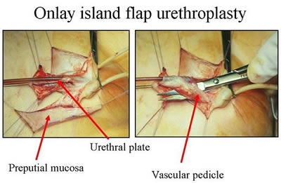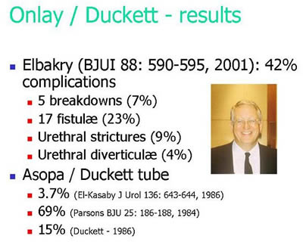
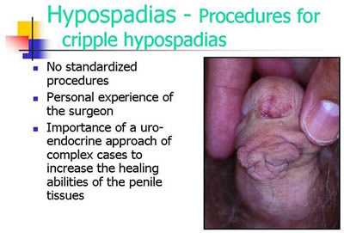
Official Diagnosis “Hypospadias Cripple”
= made a “cripple” by repeat cosmetic surgeries

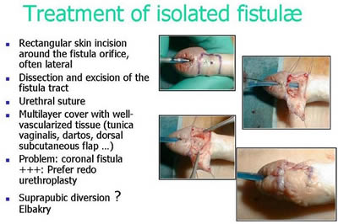
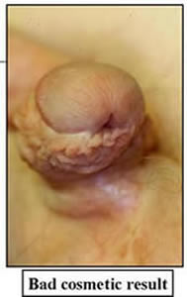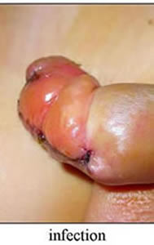
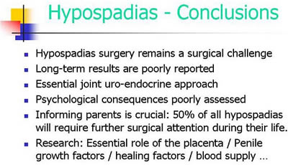
Source: Pierre Mouriquand: “Surgery of Hypospadias in 2006 - Techniques & outcomes”

IGM 2 – “Feminising Surgery”: “Clitoral Reduction”, “Vaginoplasty”
Partial amputation of clitoris, often in combination with surgically widening the vagina followed by painful dilation. “46,XX Congenital Adrenal Hyperplasia (CAH)” is arguably the second most prevalent diagnosis for cosmetic genital surgeries, and the most common for this type (further diagnoses include “46,XY Partial Androgen Insufficiency Syndrome (PAIS)” and “46,XY Leydig Cell Hypoplasia”).
Despite numerous findings of impairment and loss of sexual sensation caused by these cosmetic surgeries, and lacking evidence for benefit for survivors, current guidelines nonetheless advise surgeries “in the first 2 years of life”, most commonly “between 6 and 12 months,” and only 10.5% of surgeons recommend letting the persons concerned decide themselves later.
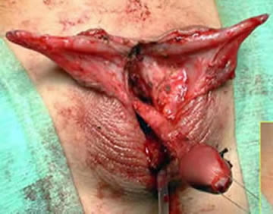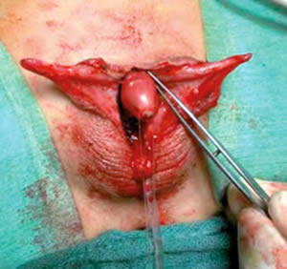
Source: Christian Radmayr (Innsbruck): Molekulare Grundlagen und Diagnostik des Intersex, 2004
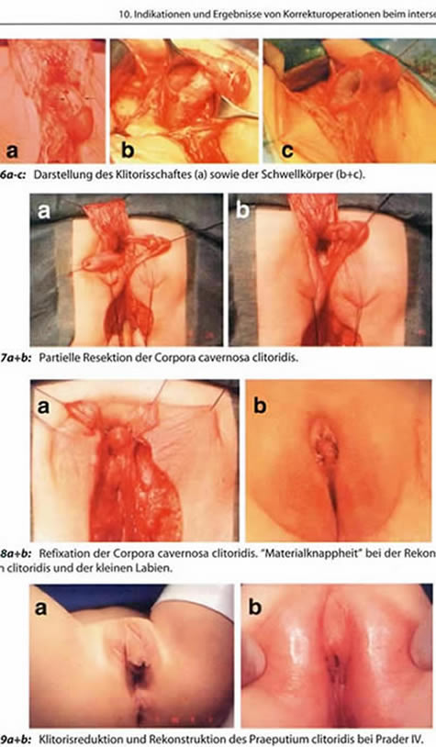
Source: Finke/Höhne: Intersexualität bei Kindern, 2008
Caption 8b: “Material shortage” [of skin] while reconstructing the praeputium clitoridis and the inner labia.
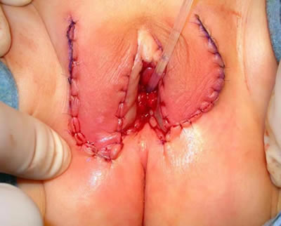
Source: Pierre Mouriquand: “Chirurgie des anomalies du développement sexuel - 2007”, at 81: “Labioplastie”
IGM 3 – Sterilising Surgery: Castration / “Gonadectomy” / Hysterectomy
Removal of healthy testicles, ovaries, or ovotestes, and other potentially fertile reproductive organs. “46,XY Complete Androgen Insufficiency Syndrome (CAIS)” is arguably the 3rd most common diagnosis for cosmetic genital surgeries, other diagnoses include “46,XY Partial Androgen Insufficiency Syndrome (PAIS)”, male-assigned persons with “46,XX Congenital Adrenal Hyperplasia (CAH)”, and other male assigned persons, who have their healthy ovaries and/or uteruses removed.
Castrations usually take place under the pretext of an allegedly blanket high risk of cancer, despite that an actual high risk which would justify immediate removal is only present in specific cases (see table below), and the admitted true reason is “better manageability.” Contrary to doctors claims, it is known that the gonads by themselves are usually healthy and “effective” hormone-producing organs, often with “complete spermatogenesis [...] suitable for cryopreservation.”
Nonetheless, clinicians still continue to recommend and perform early gonadectomies – despite all the known negative effects of castration, including depression, obesity, serious metabolic and circulatory troubles, osteoporosis, reduction of cognitive abilities, loss of libido. Plus a resulting lifelong dependency on artificial hormones (with adequate hormones often not covered by health insurance, but to be paid by the survivors out of their own purse).
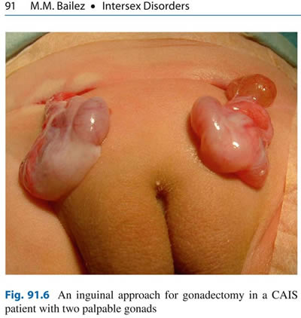
Source: Maria Marcela Bailez: “Intersex Disorders,” in: P. Puri and M. Höllwarth (eds.),
Pediatric Surgery: Diagnosis and Management, Berlin Heidelberg 2009.
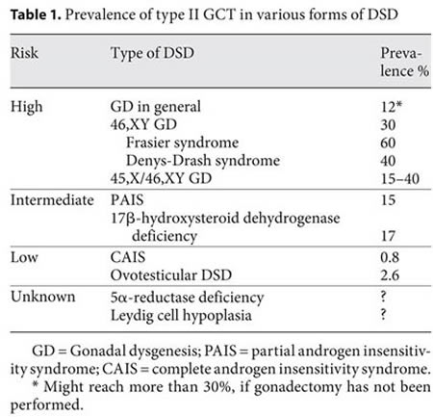
Source: J. Pleskacova, R. Hersmus, J. Wolter Oosterhuis, B.A. Setyawati, S.M. Faradz, Martine Cools, Katja P. Wolffenbuttel, J. Lebl, Stenvert L.S. Drop, Leendert H.J. Looijenga: “Tumor risk in disorders of sex development,” in: Sexual Development 2010 Sep;4(4-5):259-69.
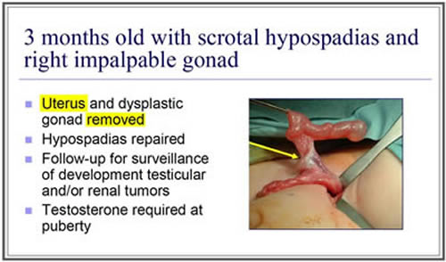
Source: J. L. Pippi Salle: “Decisions and Dilemmas in the Management
of Disorders of Sexual [sic!] Development (DSD),” 2007, at 20.
“Bad results” / “Gonadectomy, Feminizing Genitoplasty”
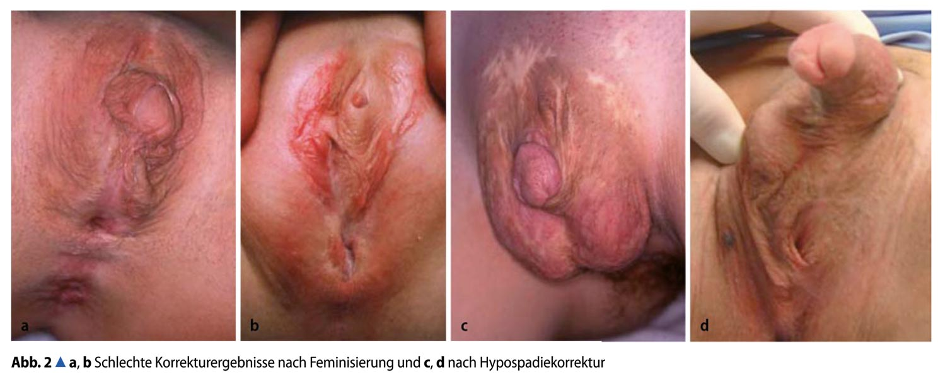
Caption: 2a,b: “Bad Results of Correction after Feminisation, and”, c,d: “after Hypospadias Repair” – Source: M. Westenfelder: “Medizinische und juristische Aspekte zur Behandlung intersexueller Differenzierungsstörungen,” Der Urologe 5 / 2011 p. 593–599.
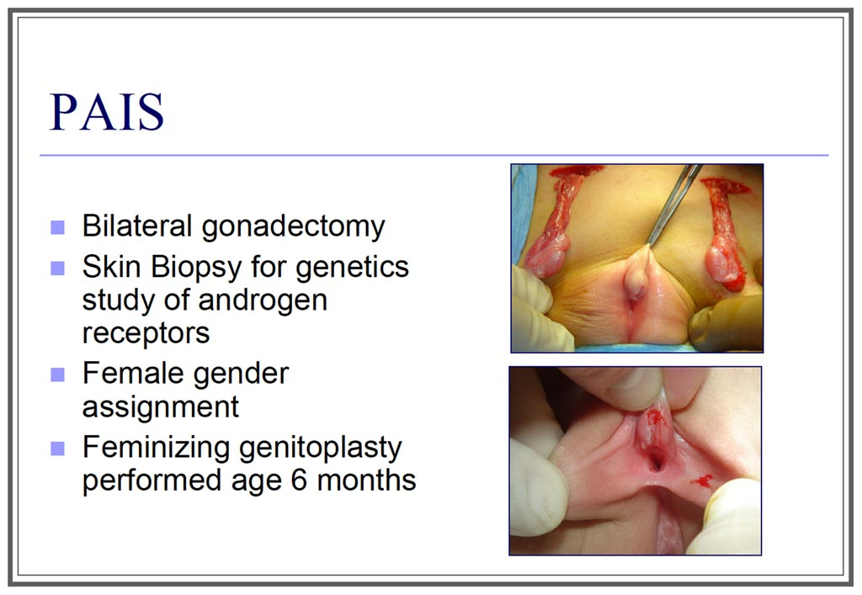
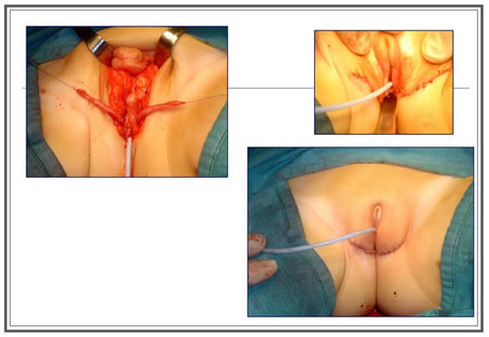
Source: J. L. Pippi Salle: “Decisions and Dilemmas in the Management
of Disorders of Sexual [sic!] Development (DSD)”, 2007, at 20.

http://Zwischengeschlecht.org/ English homepage: http://stop.genitalmutilation.org
http://zwischengeschlecht.org/post/Statuten
http://intersex.shadowreport.org
http://stop.genitalmutilation.org/post/IAD-2016-Soon-20-UN-Reprimands-for-Intersex-Genital-Mutilations
http://intersex.shadowreport.org/public/2018-CEDAW-LOI-Austria-NGO-Zwischengeschlecht-Intersex-IGM.pdf
http://intersex.shadowreport.org/public/2015-CAT-Austria-VIMOE-Zwischengeschlecht-Intersex-IGM.pdf
See http://stop.genitalmutilation.org/post/IAD-2016-Soon-20-UN-Reprimands-for-Intersex-Genital-Mutilations
For a more extensive version, see 2016 CRC UK Thematic NGO Report, p. 55–56, http://intersex.shadowreport.org/public/2016-CRC-UK-NGO-Zwischengeschlecht-Intersex-IGM_v2.pdf
UNICEF (2007), Implementation Handbook for the Convention on the Rights of the Child, at 371
CRC/C/CHE/CO/2-4, paras 42-43; CRC/C/IRL/CO/3-4, paras 39-40; CRC/C/FRA/CO/5, paras 47-48; CRC/C/CHL/CO/4-5, paras 48–49; CRC/C/GBR/CO/5, paras 45–46; CRC/C/NPL/CO/3-5, paras 41–42; CRC/C/ZAF/CO/2, paras 39–40; CRC/C/NZL/CO/5, paras 25 + 15; CRC/C/DNK/CO/5, para 24
Daniela Truffer, Markus Bauer / Zwischengeschlecht.org: “Ending the Impunity of the Perpetrators!” Input for Session 3: “Human Rights Standards and Intersex People – Progress and Challenges - Part 2” at “Ending Human Rights Violations Against Intersex Persons.” OHCHR Expert Meeting, Geneva 16–17.09.2015, online: http://StopIGM.org/public/S3_Zwischengeschlecht_UN-Expert-Meeting-2015_web.pdf
CAT/C/FRA/CO/7, paras 32–33; CAT/C/CHE/CO/7, para 20; CAT/C/DEU/CO/5; para 20; CAT/C/AUT/CO/6, paras 44–45; CAT/C/CHN-HKG/CO/5, paras 28–29; CAT/C/DNK/CO/6-7, paras 42–43; CAT/C/NLD/CO/7, paras 52-53; CAT/C/GBR/CO/6, paras 64-65
CEDAW/C/DEU/CO/7-8, paras 24(d)
CEDAW/C/LUX/CO/6-7, para 28(c)
Globally, no survivor of early surgeries ever managed to have their case heard in court. All relevant court cases (3 in Germany, 1 in the USA) were either about surgery of adults, or initiated by foster parents.
See our PSWG NGO Report, p. 8-9.
See p. 1, http://intersex.shadowreport.org/public/CEDAW73-PSWG-Austria-Written-Answers-NGO-StopIGM_web.pdf
See p. 1, http://intersex.shadowreport.org/public/CEDAW73-Austria-Intersex-NGO-Statement-Daniela-Truffer.pdf
Verfassungsgerichtshof Österreich (VFGH), 15.06.2018, Az G 77/2018-9, Rz 16, https://www.vfgh.gv.at/downloads/VfGH_Entscheidung_G_77-2018_unbestimmtes_Geschlecht_anonym.pdf
See p. 2, http://intersex.shadowreport.org/public/CEDAW73-Austria-Intersex-NGO-Statement-Daniela-Truffer.pdf
See p. 1, http://intersex.shadowreport.org/public/CEDAW73-PSWG-Austria-Written-Answers-NGO-StopIGM_web.pdf
Ibid., p. 1-2.
Steve Crilley (2017), Being Intersex in Austria, Interview with Platform Intersex Austria spokesperson and jurist Eva Matt, Radio FM4, 04.11.2017, https://fm4.orf.at/stories/2875989/

